Natural Selection
Organisms with characteristics that help them to survive in their environment have a greater chance of reproducing and producing young. Their young will inherit these characteristics. As a result the number of organisms with these favorable characteristics increases.
Here is a famous example. Below are two pictures of types of peppered moths.
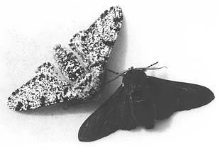
- Birds like to eat these moths. If all the trees in the environment have black bark, which moth will have the most chance of surviving? Bark is the outer “skin” of the tree.

- What is the characteristic this moth has that helps it survive?

- After 10 years which moth do you think there will be the most of?

- Use your answers to fill in the sentences that follow.
The peppered moth comes in two c_____________. Two hundred years ago pollution turned the bark of trees where the moths lived black. As a result the black moths had a characteristic that helped them to survive in their e__________________. They had a greater chance of reproducing and producing young. So over time the number of black moths increased and the number of white moths ___________________.

Natural Selection in Mice
The mice shown below live on the sand dunes near a beach. The sand is white. The mice are hunted by birds called hawks. All the mice are in the same species. Some have dark fur and some have light fur. The numbers of the different coloured mice were counted over 3 generations. Fill in the tables for the three generations and complete the questions at the end.




Generation 1


Generation 1 | Dark | White
number of mice

Generation2.








Generation 2 | Dark | White
number of mice

Generation 3.





Generation 3 | Dark | White
number of mice

- Which colour is being selected for?

- Why do you think this colour is being selected for?

We call this colour that is being selected for a FAVOURABLE CHARACTERISTIC.
Favourable characteristics increase an organism’s chances of survival.
Natural selection increases the number of organisms with favourable characteristics.

